**Visual Programming :**

**Lab 4 :**

**Roll no. 213064**

**Name : Khansa**

**Date : 9 / 10 /23**

**Examples :**

**Ex 1: ExploringNumbers()**

**Program:**

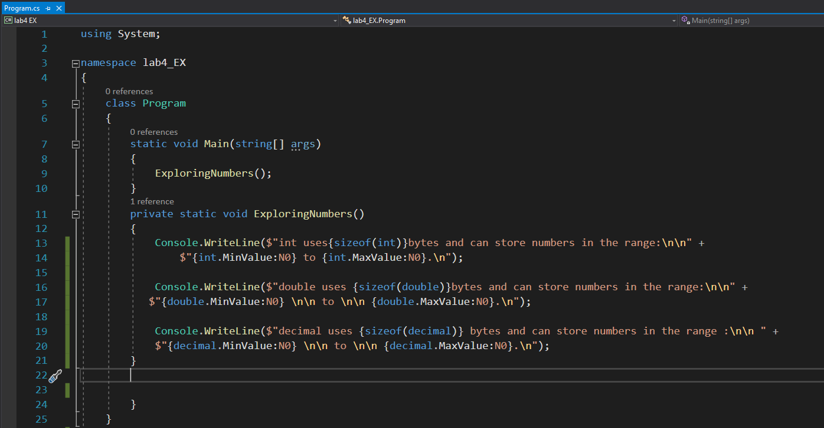

**Output :**

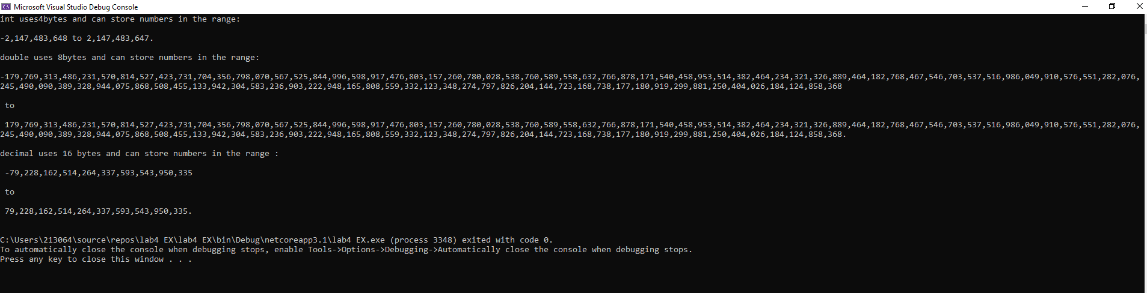

**Program 2 : AssignLocalVariables()**

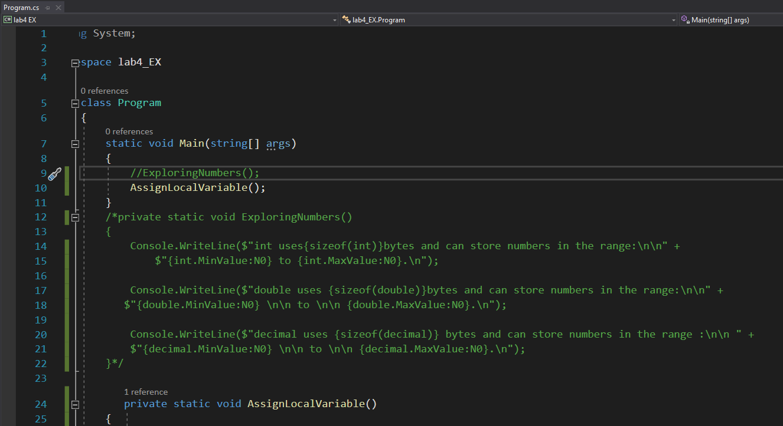

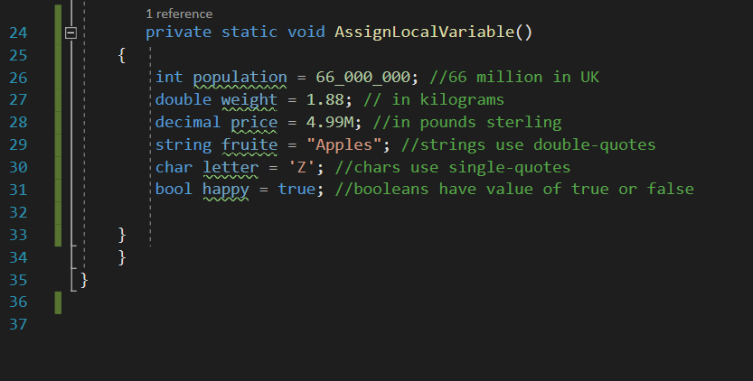

**Output :**

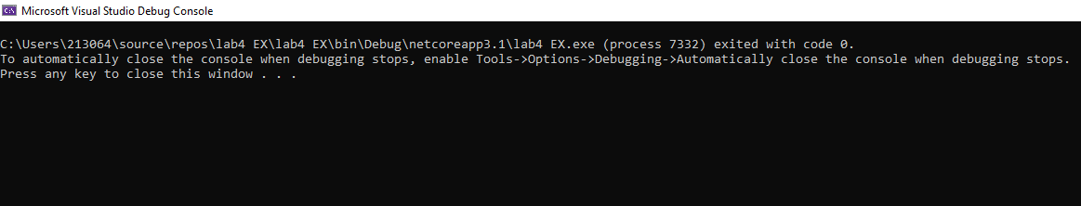

**Program 3 : C# program to demonstrate the Reference data types :**

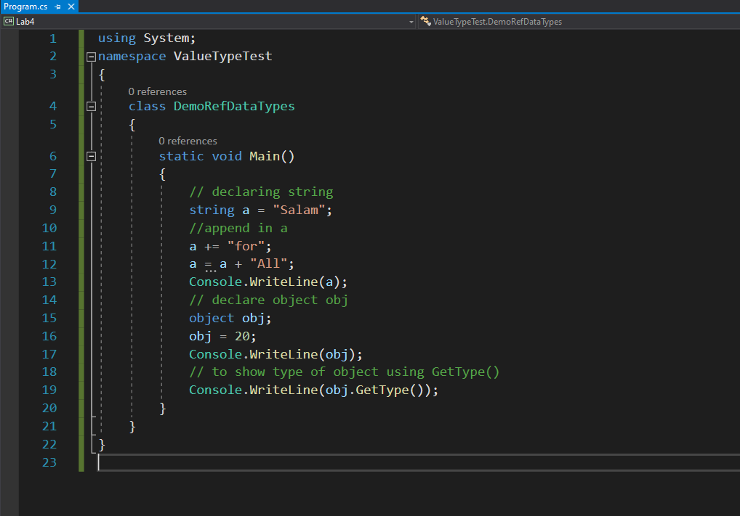

**Output :**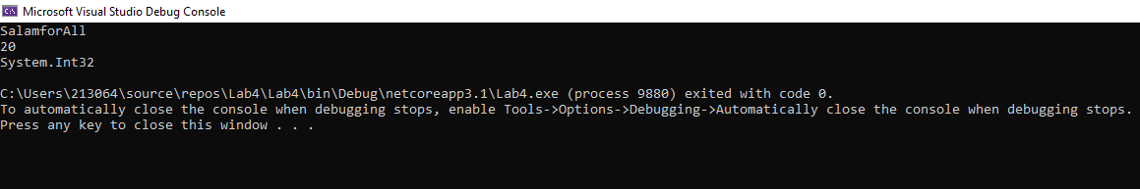

**Program 5 :**

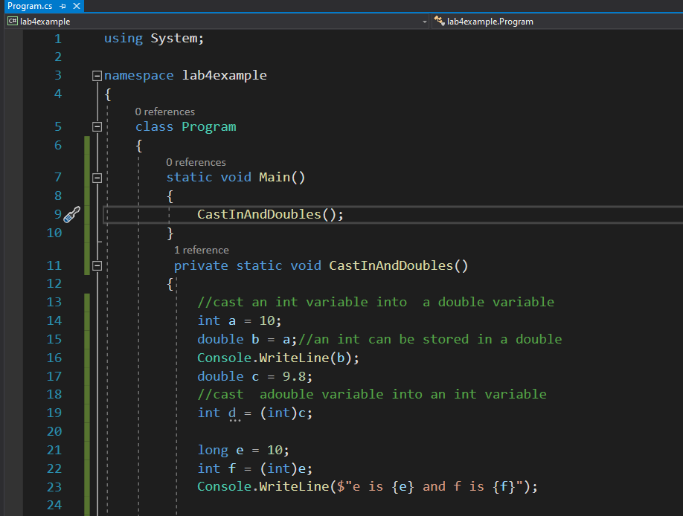

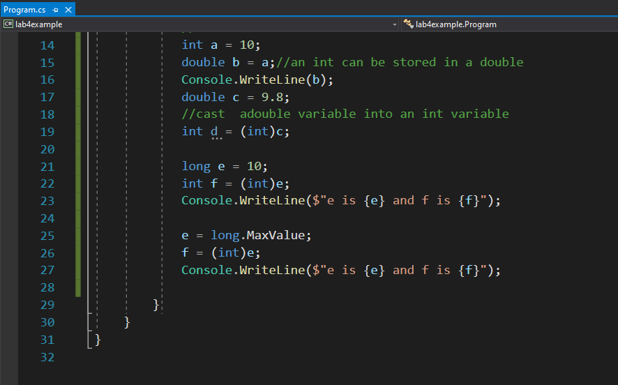

**Output :**

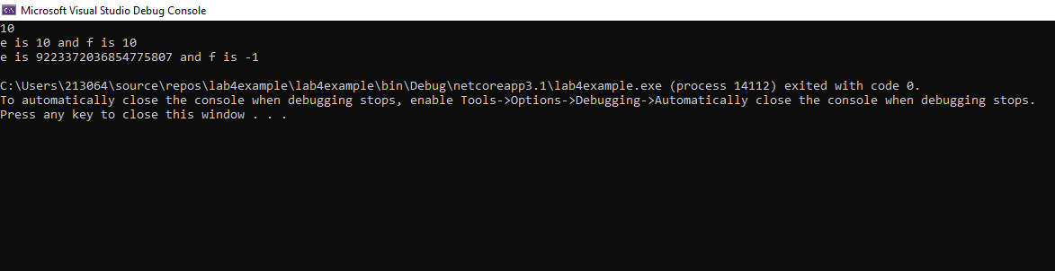

**Program 4:**

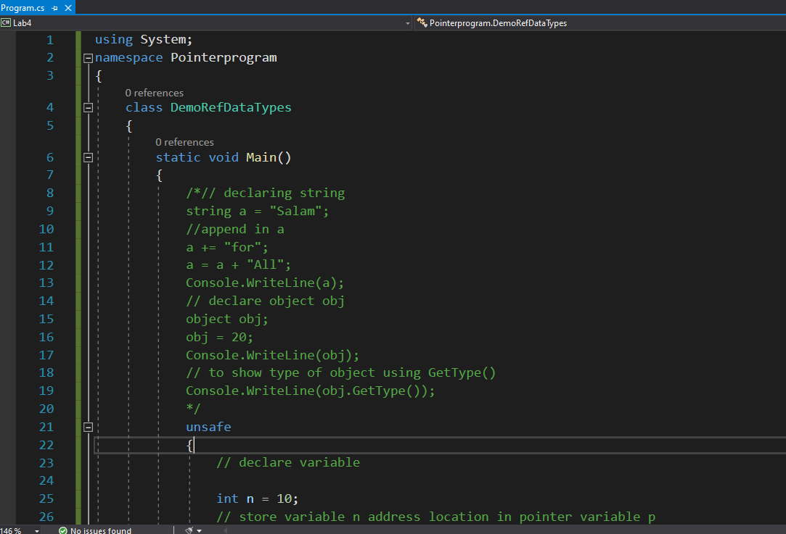

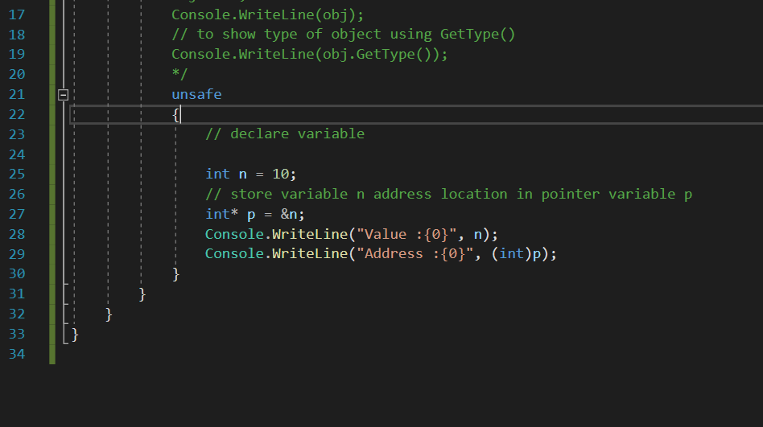

**Output :**

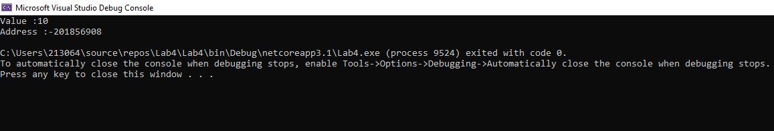

**Program 6:** **Type Conversion**

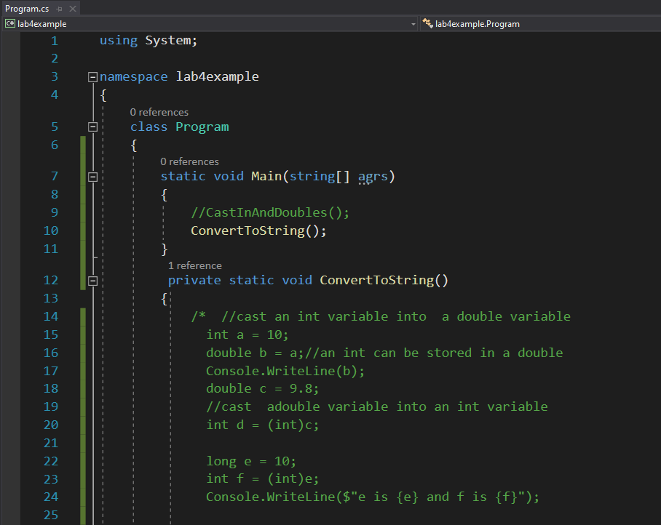

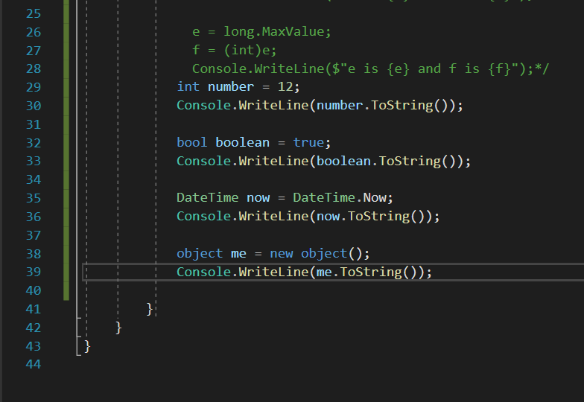

**Output:**

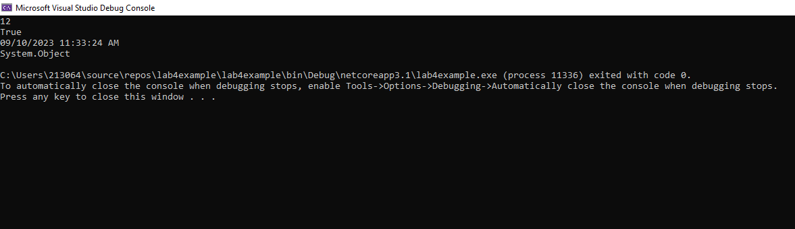

**Program 7:**

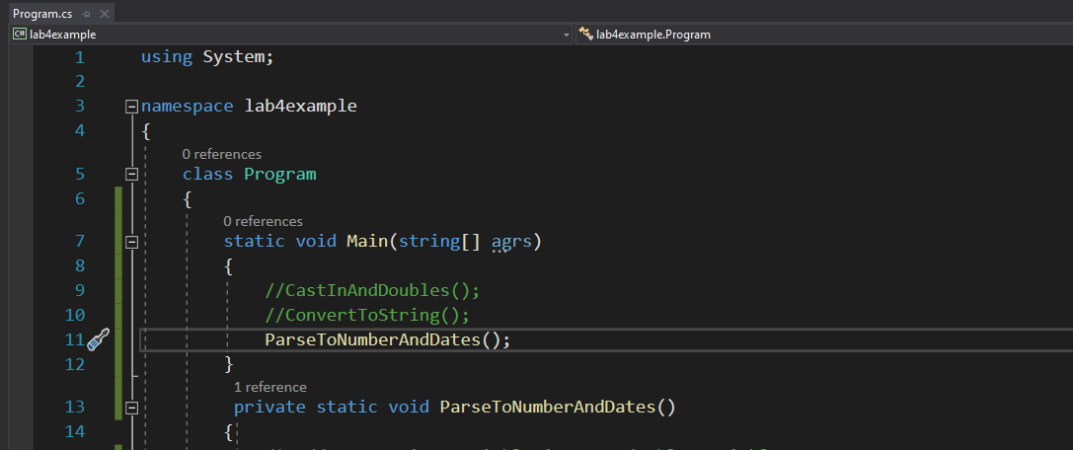

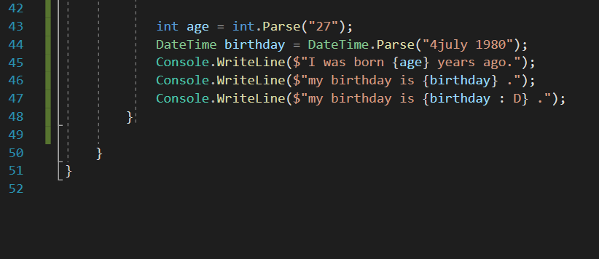

**Output:**

